1. **Show dbs:**

Show created databases.

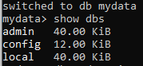

1. **Use command:**

Create db if not created else it switches to your desired db



Db mydata is not showing in the list because it is empty.

1. **insertOne() command:**

add data one by one

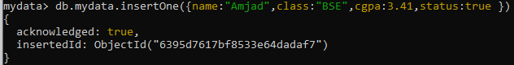

Now dbs **mydata** will be shown in the list

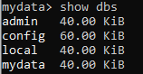

1. **find() command:**

show data of db

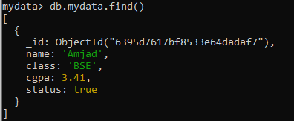

1. **show collections command:**

this shows collection name of currently working database.



1. **insertMany():**

add many data

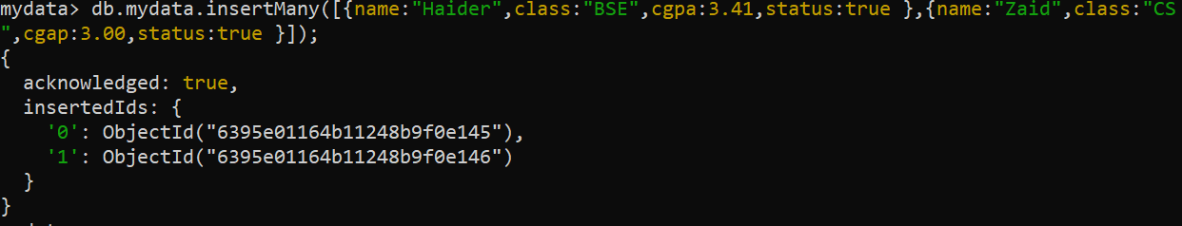

now showing our data:

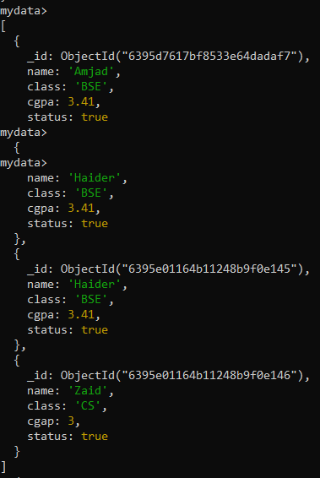

1. **Creating collection:**

**Db.collectionname.insertOne({put your desired data})**

You can also use insertMany instead of insertOne